BC Global special visit on
Christmas day to Legions of Mary at Saint Francis Church, South Sudan

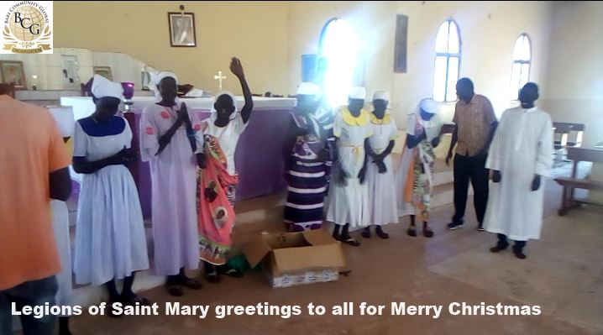

The BC Global has donated 40 pairs of flip-flops (worth $400) for Christmas to a group of sisters at Saint Francis Catholic Church north of the capital Juba, South Sudan. The Sisters called themselves Legions of Saint Mary. Most of the mothers were widows giving service to the church voluntarily, serving nursery school to cleaning the church inside and outside. Some also provided porridge to the primary school not far away from the church. In the evening, they visit houses in the village with the word of God and praise the Almighty. Their priest is from India, and he learned the native language called Bari Language. The priest blessed the Christmas gifts, with special prayers to BC Global executive officers for their continued services to the community.
BC Global Tipping Point,
In Poverty Reduction
in the new country South Sudan
Every dollar we receive goes to fight poverty. We have invested in youth empowerment through sports academies and microcredit to small farmers to restore peace and agricultural sustainability in the community.
We invest in Education to put girls and boys back to school. We invest in clean water and sanitation to reduce risks associated with lack of water. We invest in building and developing local leaders to help them be peacemakers.
Our Mission is to advance peace in the communities by supporting them in sustainable development policies.

